Foundation of care and Comprehensive Health History and Genogram Paper

It is the role of the nurse to take a comprehensive health history of their patient. It majorly assists the nurse to walk into the patients shoes and borrow important and locked in information from the shelves of secrecy within. Using this knowledge after being carefully drawn, the nurse can establish a therapeutic relationship. With continued experience in taking part in the therapeutic relationships, the nurse gains competence their communication skills. A satisfactory assessment and therapeutic communication should addresses physiological, psychological, sociological, developmental, spiritual and cultural needs of the patient. The nursing process follows a series of stages: assessment, diagnosis, planning, implementation and evaluation.
The nurse should be well equipped with the cultural wiring. Culture is inter-twinned by spiritual affairs, and if the two are wrongly approached, cases of misunderstanding may arise. There may also be cases of the patient retracting to open up. Spiritual and Cultural awareness and understanding impact’s differently on a person’s health. The nurse has a responsibility to borrow the patient’s cultural and spiritual work and knowledge. This is crucial as it ensures that the practice is sensitive and supportive of cultural issues the patient may be facing. The patient’s cultural elements may be tabled by the nurse when giving decisions and reasons that may affect the patient’s change in diet, family cohesion and closeness during quarantine (space and contact) and even need for more care and attention.

Patients with mental health feel that they are harassed and overstepped at all times. This result to fear that may outwardly be displayed as retracting from the society or violence. A nursing professional thus requires skills of great measure to break through these barriers to establish a satisfactory therapeutic sessions. Nerve calming medications maybe administered beforehand to allow for smooth session. This may work well when coming to physical assessment where the patient tries to avoid all physical contact with external environment.

BIOGRAPHIC DATA.
Name: Ola Comla
Age: 67 years
Sex: Male
Patient number: P8645312/19
General survey:
Measurement;
Height: 6”2’
Weight: 123 pounds
Pulse: 72 O/C
Neurological and mental status assessment: Response to needle prick is normal
Thorax and lung assessment: left lung has pounding bubbling sound during exhalation. A common sight for bronchitis.
Heart, neck vessel, and peripheral vascular assessment: blood pressure is normal and heart rate maintains at rest position. Vascular valves are functional.
Abdominal assessment: bowel movement is constrained with pressure bubbles. May be a course of eating foods low in diet
Musculoskeletal assessment: pain in knee joints with a clicking sound when standing upright. Common cause of lack of enough calcium for bone development. Clicking sound stops after walk exercise.
Ear, eye, nose and mouth, throat assessment: the route is clear with minimum mucous substances from the sputum as a result of bronchitis.
Skin, hair, nails, head, face, and lymphatic assessment: wrinkled skin at the limbs, neck and lower abdomen.

MEDICAL RECONCILIATION.
Calcium tablets – bone formation to reduce the clicking sound in the knees.
Hot water ginger lemon – keep clear the bronchitis from infesting into the trachea and spreading into the nasal canal.

PAST PERSONAL HEALTH HISTORY/ FAMILY HISTORY.
The family has a common thorax disorder in the form of bronchitis. The grandmother, the older brother and first born daughter suffer from the same disorder.

REVIEW OF SYSTEMS.
The patient complains of pains at the back left rib cage especially after long ours of sitting and during the early cold mornings. The patient also notes quick cut off of oxygen even after doing a light manual work.
The patient complains of clicking joints at the elbow and greatly at the knee. He explains that the clicking at the knees subsides completely after walking a few distances but returns after sitting for longer hours.

FUNCTIONAL ASSESSMENT
The patient can stand up from their sit or bed with light help of a relative’s hand or the use of their cane.
The patient also ensures that he takes constant amounts of hot water ginger lemon. The foundation of successful bronchitis management includes ongoing individual lifestyle and behavioral changes, engagement of the patient, and assessment of the patient’s level of understanding about the disease and level of preparedness for self-management. The patient will be put under strict Medical Nutrition Therapy.

Weight Management programs with frequent follow-up are required to achieve significant reductions in excess body weight. There is strong and consistent evidence that obesity management can delay progression from bronchitis treatment.

Physical Activity. Adults with bronchitis should be advised to perform at least 120 min/week of moderate-intensity physical activity. This should be encouraged to reduce sedentary time and allow renovation of bacterial infected cells. The exercise will allow expansion of airways and sufficient supply of oxygen into the body.

Comprehensive Medical Evaluation. There is need to review previous treatment and risk factor control in patients with established bronchitis. Begin patient engagement in the formulation of a care management plan for the purpose of prescribing allergy free drugs.

GENOGRAM.

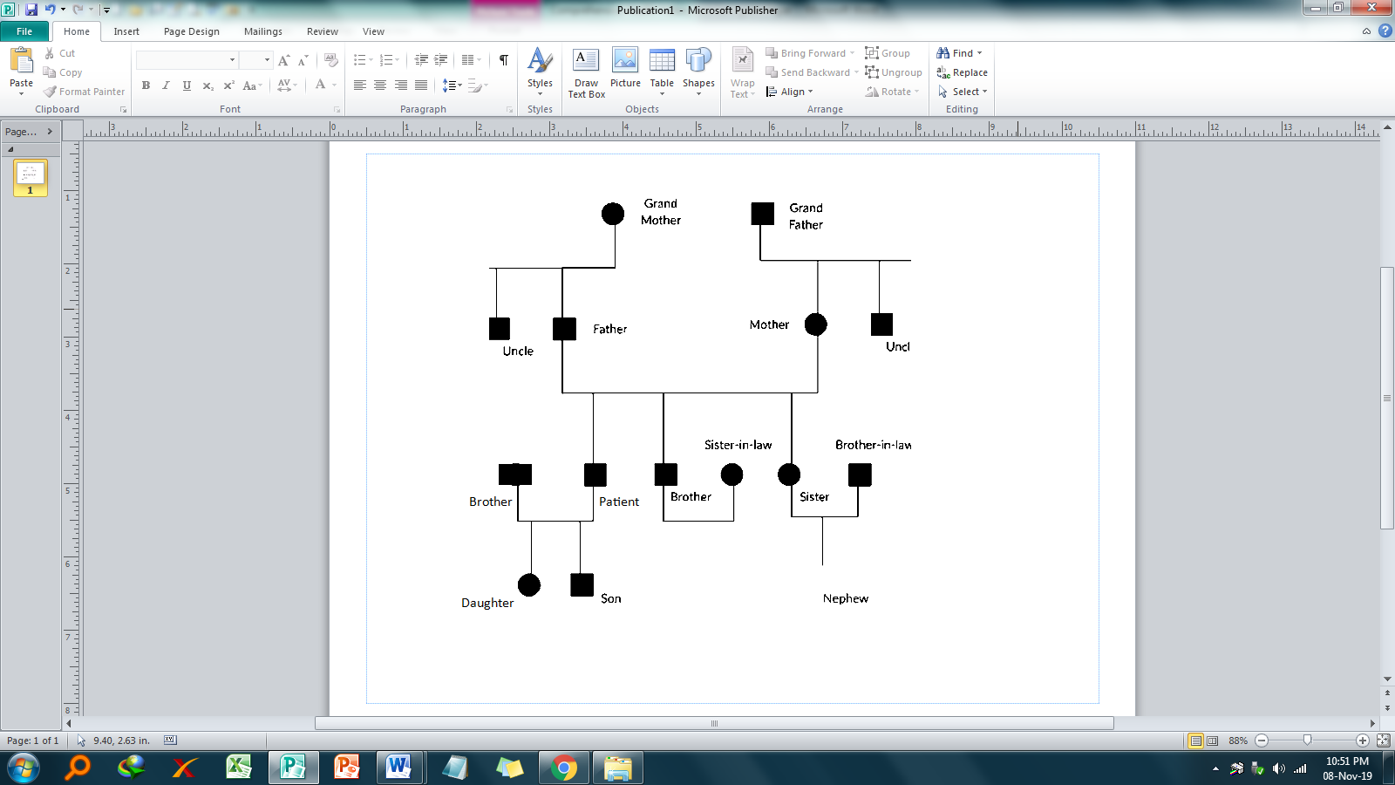

In conclusion, we can say the eye gives insight to the patient’s world, but the word of mouth gives the sight the power of voice. Therefore, the nurse should perfect n their communication skills to be used in the assessment and therapeutic sessions with their patients. Considering the code of conduct in the nurse’s professional platform, the patient is made to feel welcome to trust giving out dear information which is crucial used in combination to previous reviews to give nursing care plans.
Approach acknowledges and addresses the physiological,
Psychological, sociological, developmental, spiritual and cultural needs of the patient
Approach acknowledges and addresses the physiological,
Psychological, sociological, developmental, spiritual and cultural needs of the patient

